Domayne’s Chromium Steel Bed

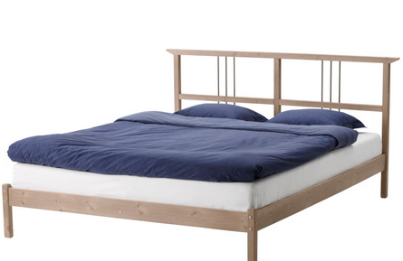

|  |
| --- |
| **DESCRIPTION** |
| Domayne introduces steel bed with a rust free zinc chromium ferrate. This set of bed is sure to create the perfect look in any home. The rich metal is perfect for use of children as it can bear a lot of harsh treatment. Perfect for any room of the house, your guests will love this comfortable mood lifting bed. |

|  |  |  |
| --- | --- | --- |
| **Price** | **700$** | |
| **Dimensions** | **H** x **W** x **L** | **28in x 54in x 75in** |
| **Features** | **Rust free metal with Greek chromium steel linkage, Handles pressure up to 3000 square tons.** | |
| **Finished** | **Natural Chromium Color** | |
| **Available in** | **Shined Chrome** | |